2.Static Router Configuration
Router Basics and Directly Connected Routing
Objective
To configure Static Routing between two Cisco routers and enable communication between two different Local Area Networks (LANs).
Topology
- 2 Cisco 1941 Router
- 2 Cisco 2960 Switches
- Each switches are connected in 9 PC’s
IP Addressing
LAN1
- Router G0/0 : 192.168.1.1/24
- PC0 : 192.168.1.2/24
- PC1 : 192.168.1.3/24
-PCN: 192.168.1.N/24
LAN2
- Router G0/1 : 192.168.2.1/24
- PC0 : 192.168.2.2/24
- PC1 : 192.168.2.5/24
-PCN: 192.168.2.N/24
Router Configuration:
->Open the router command line interface
->router> it is normal user command line
1. enable – The router gives the administrative permission
The output: Router#
2.config t / configuration terminal – It set the configuration of the router settings
3.interface gigabitethernet0/0 – we will select the g0/0 for configuration
4.ip address 192.168.1.1 255.255.255.0 – to assign the ip address and also subset for
G0/0
5.no shutdown – default router is shutdown so we say no shutdown
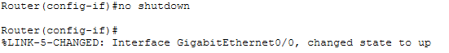
6. exit
7.(LAN -2)select another gigabitethernet1/0 and configure
8.To assign the ip address and subset address
9.no shutdown
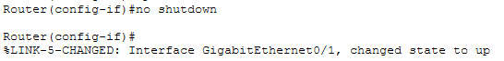
10. end – end of the configuration
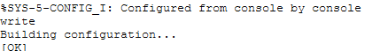
11.show ip interface brief – configured ip are showed.
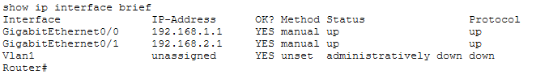
12. Again we configure the Router 2 following above steps:
13.The configuration is over then we configure the static configuration of both router
Command: ip route 92.168.2.1 255.255.255.0 10.0.0.2 for router 1
show ip route
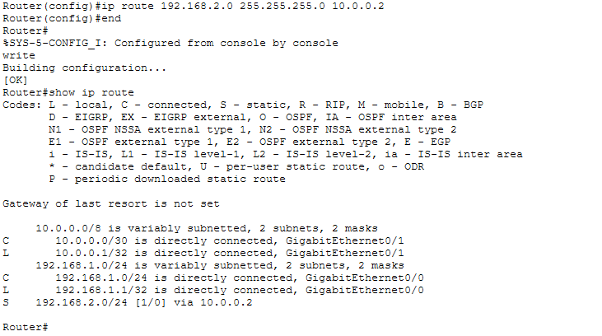
The output 192.168.2.1/24 [0/1] via 10.0.0.2 the static configuration of the router is correct.
Command: ip route 192.168.1.1 255.255.255.0 10.0.0.1 for router 2
show ip route
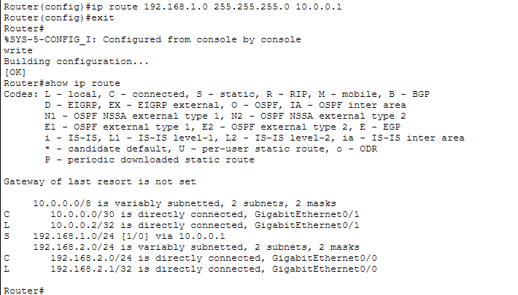
Testing
Step 1: Verify Same Network Communication
Open Command Prompt on PC0.
Ping another PC in the same LAN.
Example:
ping 192.168.1.3
Expected Result:
The ping should be successful, confirming communication within the same LAN.

Step 2: Verify Different Network Communication
Open Command Prompt on PC0.
Ping a PC located in another LAN.
Example:
ping 192.168.2.2
Expected Result:
The ping should be successful, confirming that Static Routing is working correctly and communication between different LANs has been established.

Step 3: Verify Router Connectivity (Optional)
From the router CLI, verify connectivity between the routers.
ping 10.0.0.2
Expected Result:
Successful replies indicate that the router-to-router link is functioning correctly.
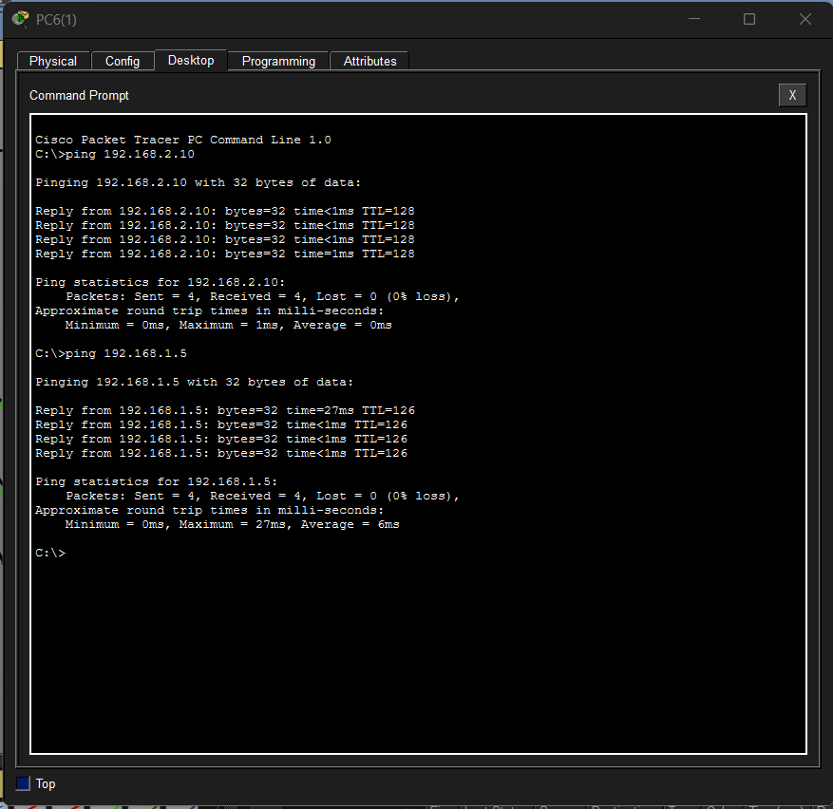

Result
Successfully configured Static Routing between two Cisco routers using Cisco Packet Tracer. Communication between two different LANs was established by configuring IP addressing, default gateways, and static routes. The network connectivity was verified using ping, show ip interface brief, and show ip route commands.
Output:
